31. print the pattern

1

22 333 4444 55555

#include <iostream>

int main() {

int rows;

std::cout << "Enter the number of rows: ";

std::cin >> rows;

for (int i = 1; i <= rows; ++i) {

for (int j = 1; j <= i; ++j) {

std::cout << i;

}

std::cout << std::endl;

}

return 0;

}

OUTPUT: 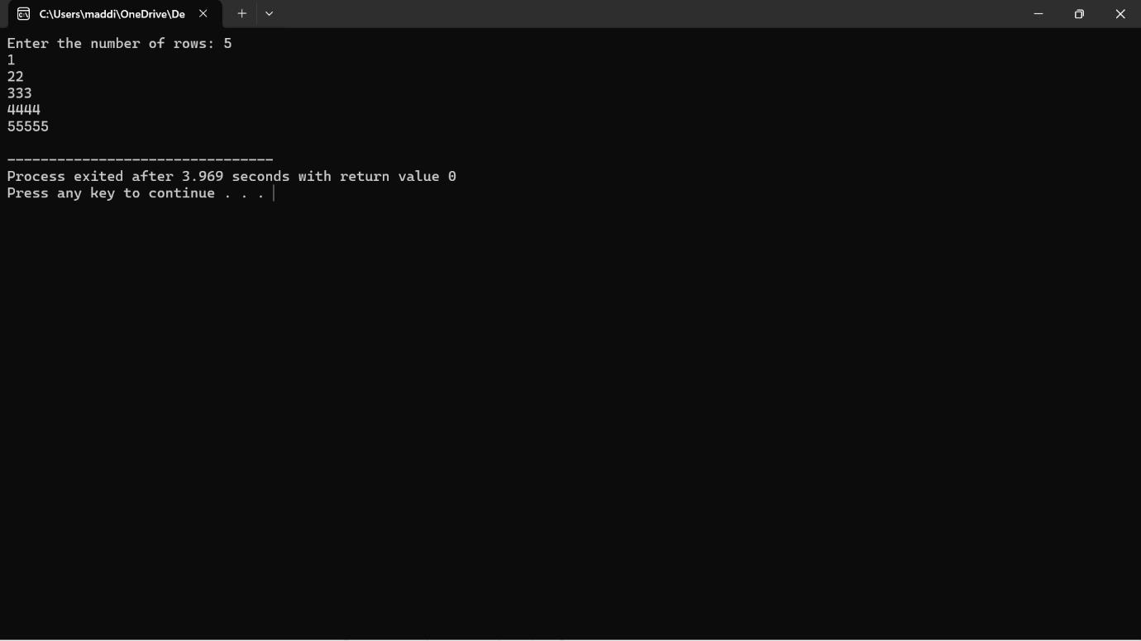

32. print the pattern \*

\*\* \*\*\* \*\*\*\* \*\*\*\*\*

#include <iostream>

int main() {

int rows;

std::cout << "Enter the number of rows: ";

std::cin >> rows;

for (int i = 1; i <= rows; ++i) {

for (int j = 1; j <= rows - i; ++j) {

std::cout << " ";

}

for (int k = 1; k <= i; ++k) {

std::cout << "\*";

}

std::cout << std::endl;

}

return 0;

}

OUTPUT: 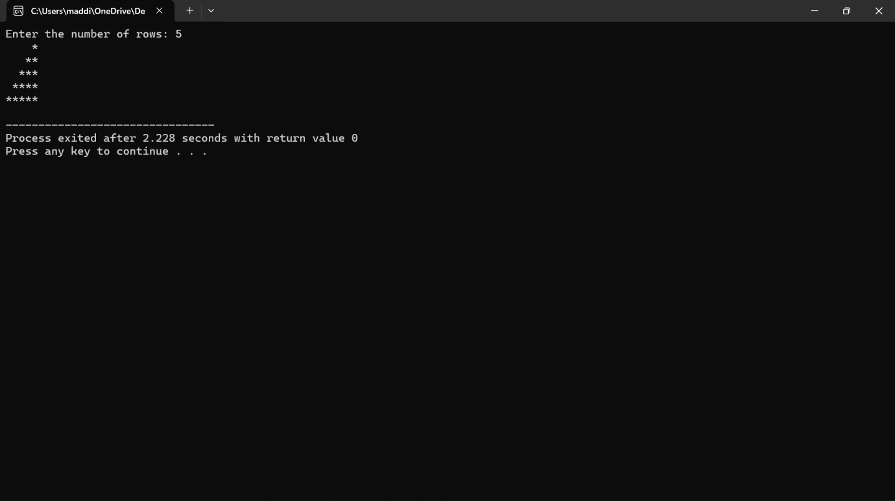

33. Print pascal triangle pattern nested for loop

#include <iostream>

int main() {

int rows;

std::cout << "Enter the number of rows for Pascal's triangle: ";

std::cin >> rows;

for (int i = 0; i < rows; i++) {

int number = 1;

// Print spaces for formatting

for (int j = 1; j <= rows - i; j++) {

std::cout << " ";

}

for (int j = 0; j <= i; j++) {

// Print current number

std::cout << " " << number;

// Calculate the next number using the formula: nCr = n! / (r! \* (n-r)!)

number = number \* (i - j) / (j + 1);

}

std::cout << std::endl;

}

return 0;

}

OUTPUT: 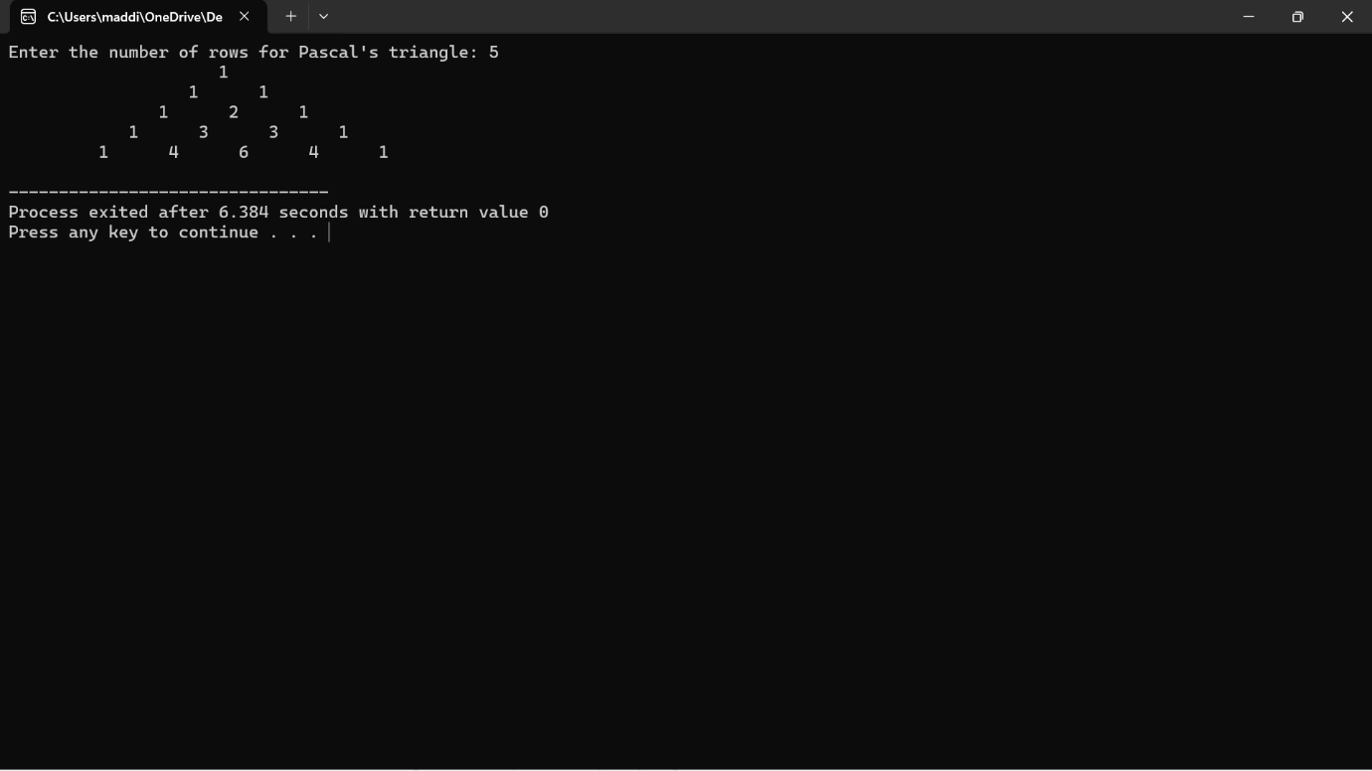

34. Print diamond pattern with \* using nested for loop

#include <iostream>

int main() {

int rows;

std::cout << "Enter the number of rows (odd number): ";

std::cin >> rows;

// Upper part of the diamond

for (int i = 1; i <= (rows + 1) / 2; ++i) {

for (int j = 1; j <= rows - i; ++j) {

std::cout << " ";

}

for (int k = 1; k <= 2 \* i - 1; ++k) {

std::cout << "\*";

}

std::cout << std::endl;

}

// Lower part of the diamond

for (int i = (rows - 1) / 2; i >= 1; --i) {

for (int j = 1; j <= rows - i; ++j) {

std::cout << " ";

}

for (int k = 1; k <= 2 \* i - 1; ++k) {

std::cout << "\*";

}

std::cout << std::endl;

}

return 0;

}

OUTPUT: 